How to Enroll a Wellness Advocate

To enroll someone login to your doterra acct at mydoterra.com.

Go to the Dashboard Tab

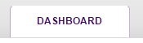

On the top right corner you will see a rectangle box that says - Enroll a Wellness Advocate - click there

Select the Wholesale Prices Option

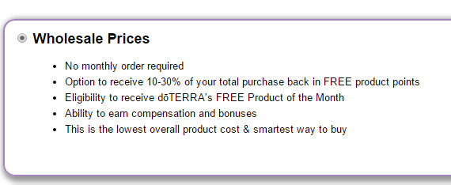

Follow prompts from there

doTerra asks for SSN in case the person becomes a builder. They will receive a 1099
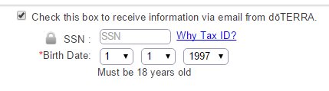

When asked for Enroller ID, this is you. Type in your id number and click verify id
Sponsor ID – is used if you are enrolling the person but you want to place them under someone else
If this is not the case, leave this blank
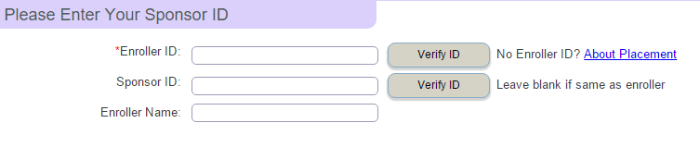

After placing initial order, click to setup the next recurring order, this will create their LRP

Be sure to ask what they may want for next month if they are signing up for LRP.

Show them how to login themselves and change cart

Also tell them about the monthly promotions

