To log in to your account go to www.mydoterra.com
Member #: This is the ID number you were given when you signed up
Password: sunset – feel free to change
From here you can create and/or manage your LRP order each month. Ordering via LRP is how you will earn points for free product each month.
If you already have an LRP Template setup, click the gray oval box with your order #
If not, click Create a New LRP Template
If you select Place Standard One Time Order, you will not receive LRP points
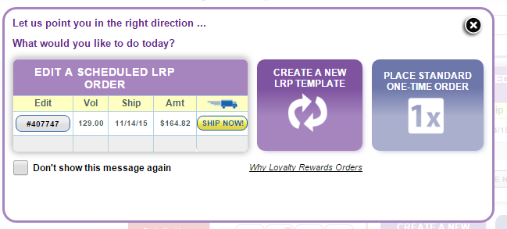
To do this:
- Click ‘CREATE NEW LRP ORDER’ or click on your existing LRP on the right to update the order (it will be in a gray oval with your order # in it that you can click on)
- Select a process date (remember if your order processes by the 15th & is 125PV, you will earn the FREE Oil of the Month) – if your LRP is already setup, this will already be selected
- Click ‘Shop Now’ at the bottom of the calendar and begin to add items to your cart
- Remember to ‘Save Changes’ before exiting your shopping cart
You can place as many LRP orders as you like between the 1st & the 28th of each month, (you will notice that some dates are not available). Make sure to click the ‘Save Changes’ button at the bottom each time you make any changes to your items, shipping, or payment information.
*If you need to cancel your LRP order for any reason, call dōTERRA at 800-411-8151. Keep in mind you will lose all accumulated points & your earning percentage will go back to 10%
**Contact me with ANY questions!! I am always available to help any time something comes up!!

